**The Saint Paul’s**

**Alumni Association Presents**

**Friday**

**November 14, 2025**

**Tchefuncta**

**Country Club**

**Covington, LA**



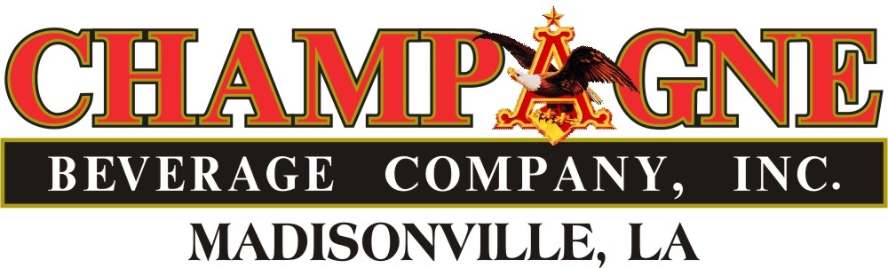

**Hole in 1 - win a car!**

**Hole in 1 - win a Car!**



**SCHEDULE OF EVENTS**

**8:00 a.m. – 9:00 a.m. – Registration, Breakfast, Invocation and Instruction**

**9:00 a.m. – 3:00 p.m. – Shotgun Start and Tournament**

**3:00 p.m. – 3:30 p.m. – Awards Party**

**ENTRY FEES:**

**Foursome- $1000 includes four green fees, cart rental, tournament giveaway, ditty bag, refreshments, breakfast, lunch, after party, awards and prizes.**

**HOLE SPONSORSHIP**

**BLUE ($1200)**

* Foursome
* Sign on Course
* Intermediate Signage on Sponsor Board
* Donor recognition in Wolf Tracks and event promotions

**WHITE ($300**

* Sign on Course
* Sign on Sponsor Board
* Donor recognition in Wolf Tracks and event promotions

**GOLD ($1500)**

* Foursome
* 4 Crawfish Cook-Off Tickets
* Sign on Course
* Premium Signage on Sponsor Board
* Donor recognition in Wolf Tracks and event promotions

[ ] **I will have a FOURSOME** of these players (Enclose $1000.00 )

Name: Handicap:

Name: Handicap:

Name: Handicap:

Name: Handicap:

**I will be a SPONSOR**

**[ ] White** ($300)

**[ ] Blue** ($1200)

**[ ] Gold** ($1500)

**Name to appear as SPONSOR**

**Name_________________________________________________**

**Phone Number_________________________________________**

**Email_________________________________________________**

**Mailing Address________________________________________**

**________________________________________**

**Make checks payable to: Saint Paul’s School - P.O. Box 928- Covington, LA 70434**

**To Pay Online by card please visit: https://www.stpauls.com/alumni/alumni-events/golf-tournament/**

**For Further information, please contact Al Nastasi at 985-892-3200 ext 1971**

Disclaimer: In the event of inclement weather, thank you for your donation