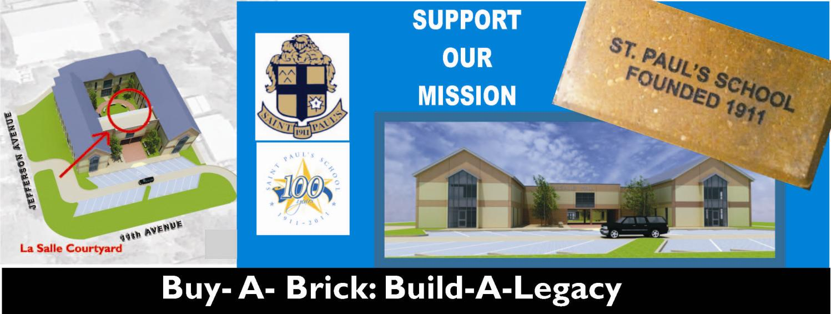







**(Remember that periods and spaces between words are counted as characters)**

**Max number of characters 18 per line**

**Brick Contribution ~~$125~~ $100**

**Name: ___________________________________**

**Please make checks payable to:**

**Saint Paul’s School**

**Buy-a-Brick**

**917 S. Jahncke Ave.**

**Covington, LA 70433**

**Year of Graduation: ________________________**

**Email: ___________________________________**

**Address: _________________________________**

**City, State, Zip: ____________________________**

**Phone: ___________________________________**

**VISA/MC: ______ - ______ - ______ - ______**

**Exp: ___/___ CVC: ______**

**Signature: ____________________ Date: _______**