**The Saint Paul’s**

**Alumni Association Presents**



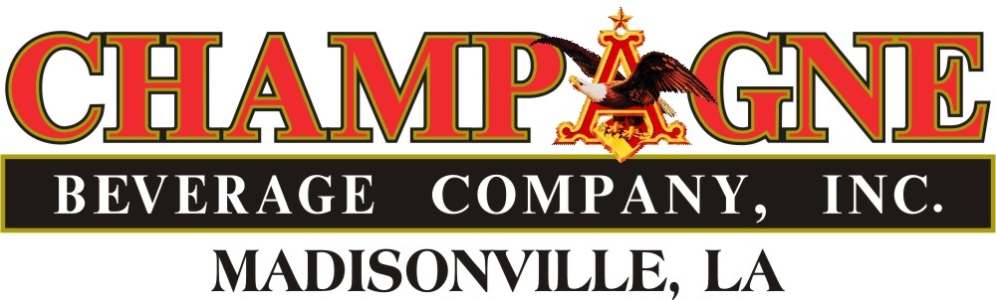

**Friday**

**September 29, 2023**

**Tchefuncta**

**Country Club**

**Covington, LA**

**Hole in 1 - win a car!**

**Hole in 1 - win a Car!**



**SCHEDULE OF EVENTS**

**8:00 a.m. – 9:00 a.m. – Registration, Breakfast, Briefing and Invocation**

**9:00 a.m. – 3:00 p.m. – Shotgun Start and Tournament**

**3:00 p.m. – 3:30 p.m. – Awards Party**

[ ] **I will have a FOURSOME** of these players (Enclose $800.00 )

Name: Handicap:

Name: Handicap:

Name: Handicap:

Name: Handicap:

**[ ] Place me in a FOURSOME** (Enclose $200.00) (Please contact Al Nastasi to verify)

**Name:**

**[ ] I will be a SPONSOR** (Circle one: **White** ($300) **Blue** ($1000) **Gold** ($1300)

**Name to appear as SPONSOR**

**[ ] Sorry, I cannot play. Here’s my contribution of $**

**GOLF PACKAGE- Will be available the day of the event**

**DITTY BAGS**: Donation deadline 9/22/23- please contact Al Nastasi for further details

**Name:**

**Address:**

**Phone:**

**Email:**

**PLEASE PRINT: Make checks payable to: ST.PAUL’S ALUMNI ASSOCIATION- P.O. Box 928- Covington, LA 70434. Contact Al Nastasi –** [**aln@stpauls.com**](mailto:aln@stpauls.com) **985-892-3200 ext 1971 for further questions.**