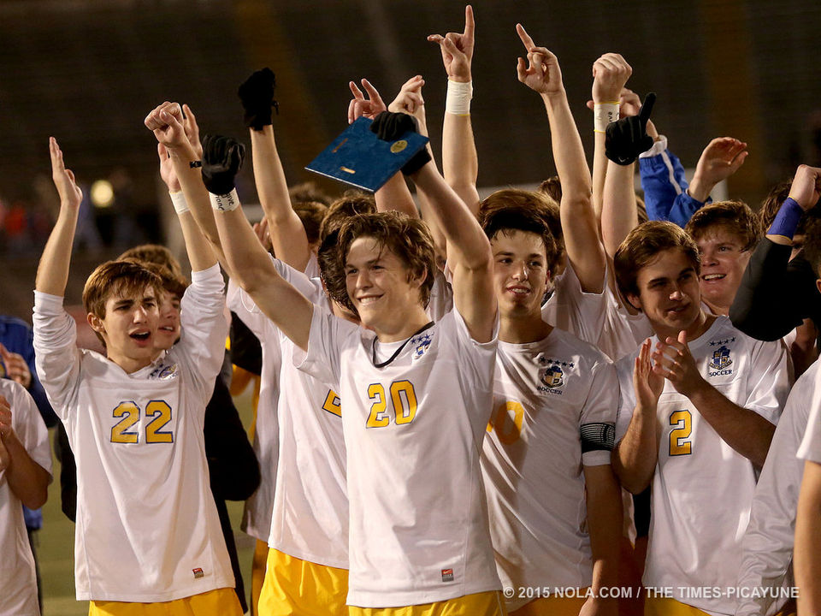

***Congratulations to State Champion Soccer Wolves!***

***The President's Newsletter for Mar 02 - 08, 2015***

Remember that you are dust and to dust you shall return!

**Lent is a Time to Feast and Fast**

Fast from judging others. *Feast* on the God within them.

Fast from emphasis on differences. Feast on the unity of all life.  
Fast from apparent darkness. Feast on the reality of light.  
Fast from thoughts of illness. Feast on the healing power of God.  
Fast from discontent. Feast on gratitude.  
Fast from anger. Feast on patience.  
Fast from pessimism. Feast on optimism.  
Fast from worry. Feast on God’s love for you.

Sister Margaret Murray, CSJ

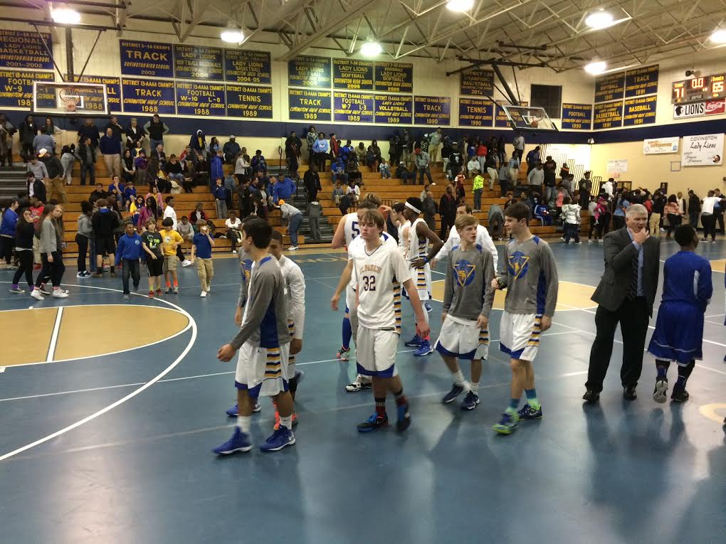**Mon, Mar 2 (Regular; G A B C)**

* **TDIH:** In 1904, Theodor Seuss Geisel (aka Dr. Seuss) was born. Read a Dr. Seuss book today! Celebrate with green eggs and ham and oh, the places you’ll go!
* **National Banana Cream Pie Day:** Enjoy – unless you’ve given it up for Lent!
* **Rising Senior Scheduling Assembly**

**Tue, Mar 3 (Assembly; D E F G)**

* **TDIH:** In 1931, Congress makes The Star Spangled Banner the National Anthem of the United States. Sing it today! Do you know who wrote it and on what occasion?

*Tired but victorious Wolves leave the court after thrilling playoff win*

* **I Want You to be Happy Day** is an unselfish day. It’s a thought that we wish upon others that we care for or love. Celebrate today by doing more than wishing someone is happy. Do something to make others happy.
* **President’s Rising Junior Schdling Assemb**
* **Baseball:**  JV & Varsity at John Curtis (Mike Miley Park); 8th v. Rummel (4:30)
* **Tennis:** Wolves at Slidell
* **Golf in Northshore League**
* **Basketball:** Wolves travel to Natchitoches to take on #1 seed Natchitoches Central in round two of the playoffs. We pray for their safe travel!

**Wed, Mar 4 (Regular; A B C D)**

* **TDIH:** In 1933, the Great Depression height, Franklin Roosevelt was inaugurated as the 33rd US President.
* **National March Forth and Do Something Day (**get it? March Fourth and March Forth?) Stop wasting valuable time, do something for once, and stop procrastinating!
* **National Grammar Day:** Language is something to celebrate, and March 4 is the perfect day to do it. It's not only a date, it's an imperative: March forth on March 4 to speak well, write well, and help others do the same!
* **Rising Sophomore Scheduling Assembly**

**Thu, Mar 5 (Regular; E F G A)**

* **TDIH:** In 1946, Winston Churchill delivers his “Iron Curtain” speech in Fulton, Missouri.
* **Rising Sophomore Scheduling Assembly**
* **Baseball:** 8th in Holy Cross tournament; Varsity v. Destrehan (4:30)
* **Celebrity Waiters Dinner**
* **Distribution of Senior Graduation supplies by Balfour (theater lobby during lunch)**

**Fri, Mar 6 (9 am start; B C D E)**

* **TDIH:** In 1912, the National Biscuit Company introduces the Oreo Cookie! Dunk an Oreo today!
* **Dentist Day:** Appreciate your dentist today, especially our SPS parents and alums who are dentists!
* **Baseball:** 8th in Holy Cross tournament; (5:30); Varsity v.Dutchtown (4) & Lakeshore (6:30)
* **Track:** JV & Varsity in F’Bleau Meet
* **Lacrosse:** 8th v. Christian Brothers

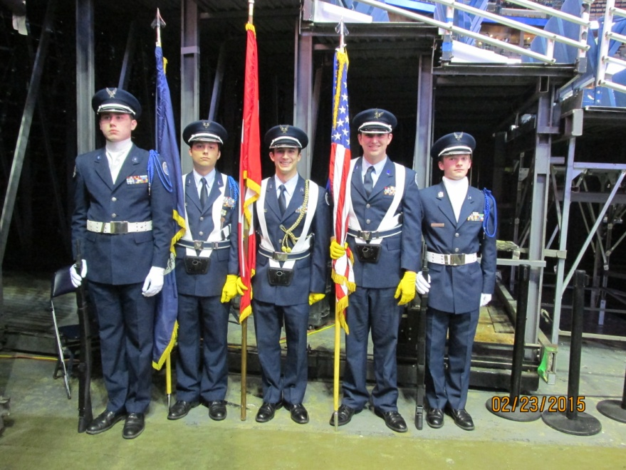

**Sat, Mar 7**

* **TDIH:** In 1923, *The New Republic* publishes Robert Frost's poem "Stopping By Woods on a Snowy Evening." The poem, beginning with the famous line "Whose woods these are, I think I know. His house is in the village though," has introduced millions of American students to poetry. Re-read this classic today!
* **World Math Day!** Celebrate & work math problems!
* **B’ball:** 8th in Holy Cross Tourn; 9th at Mandeville (11 &1:30)
* **ACT Prep Course (9-1)**

*LA 41st Color Guard presents colors at Pelicans’ game last week. Since the Pels were playing the Toronto Raptors, the Canadian flag was also presented.*

* **Lacrosse:** JV & Varsity in Memphis for various games
* **Rugby v. Houma**
* **SPS Baseball Patron Party at the Triple Nickel Grill (7)**

**Sun, Mar 8 – Third Sunday of Lent**

* **Daylight Saving Time begins at 2 am! Spring forward!**

**Scheduling Assemblies:** Students who have registered will receive their course selection materials for next year. They will receive priority in the scheduling process. If you want your son in this number and you haven’t registered but into to return, please do so ASAP. If your son is not returning, please have the courtesy of letting me know so I can fill his spot from our applicant pool. Thank you.

**What I Did On My San Diego Vacati... uh…Conference:** I know you’re anxious to learn what we did in San Diego for four days last week, so:

* Sunday afternoon: checked into San Diego Mission Valley Marriott Hotel (nice!) The conference began at 6 with mass celebrated by Father Brian O’Brien, President of Bishop Kelley High School in Tulsa, OK. Father Brian is one of two priests who are presidents of Lasallian high schools in the US/Canada region. The other is Father Paul Novak, President of De La Salle Institute in Chicago. Very moving! Actual anecdote: the priest’s chasuble got caught in the chair and he couldn’t move! He ended up wiggling out of the chasuble while half-sitting and half-standing – which made for a hilarious scene! Each of the next three days began with an excellent prayer service.
* After mass, we viewed a statistical analysis of the Lasallian systems in the region over the past year: enrollment is slightly down, staffing is up, Brothers and other religious are down, & tuition is up. We then had the keynote address by Brother Tom Johnson. Brother Tom has held numerous leadership positions in the Brothers. The title of his talk was High Velocity Lasallians in a High Velocity World. Very interesting – and challenging! We then had a very nice social (the chardonnay was great!) to reacquaint ourselves with our colleagues and relax from our day’s travel.
* Monday: Our prayer centered on “The Work is Yours” – which should be a familiar mantra to all Lasallians. We then had a “business meeting” of our association: financial statement, dues structures, election of a new vice-president and a few other “business type” things.
* 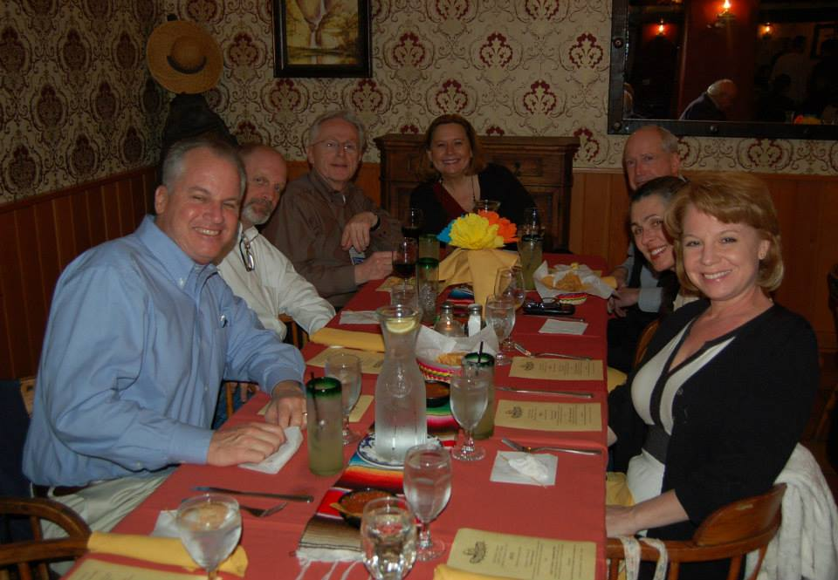We spent the rest of the day with three sessions led by Dr. Marisa Guerin, president of Guerin Management Consulting. The first session was entitled “Leading Teams: Navigating a High Velocity World.” The second was “Leaders and Culture: Remarkable, Perilous or Toxic.”
* We then had an excellent Mexican cuisine lunch. I ate more in those 3 days than I usually do in more than a week.
* The afternoon session was “Leadership Succession: Best Practices for a Lasallian Future.” This last one really got me thinking – as I know my time at SPS will one day end.

*Lasallians at LASSCA, l to r: Joey Scaffidi (President, Christian Brothers School in City Park), Trevor, Brother Edmond Larouche (President, St. Mary’s College High School in Berkeley), Mary Hesser (Principal, Christian Brothers High School in Sacramento), yours truly, Candace Watkins, & Lisa Scaffidi.*

* On Monday night, the San Francisco New Orleans District contingent boarded a San Diego trolley and traveled to a local Italian restaurant named Buca di Beppo – which, while very nice, can’t compare to New Orleans restaurants! But we “passed a good time” – I’ll leave it at that! After an rather exhausting day, we retired for the night!
* On Tue, our prayer centered on “The Virtue of Humility.” Then, Mr. Sean Callahan, COO of Catholic Relief Services on leadership techniques, maintaining culture and charism while embracing change, and being Church in the time of Pope Francis. I had no idea CRS did so much in so many parts of the world!
* I then met with the Presidents of Lasallian schools while Trevor met with principals. We discussed a wide variety of common problems involved in school governance, canon law, technology, professional development, admissions, and development.
* Following another great lunch, the Districts met. We spoke about finances, formation programs, wine sales for financial aid (very Californian!) and other District business.
* On Tue evening, we again boarded the trolley and went out for dinner. Very nice! As in Vegas, though, what went on at Fiestas de Reyes stays at Fiesta de Reyes! Sleep was very welcome that night.
* On Wed morn, we had about a 60 minute prayer breakfast, which centered on the importance of personal sanity and serenity. Cheri Broadhead, principal of Totino-Grace High School in Fridley, Minnesota, and Gary Cannon, principal of Sacred Heart Cathedral Preparatory in San Francisco, California, shared personal reflections. Cannon explained how it’s vital for leaders to take things as they come and ended by telling participants to “see yourself as God sees you.” We then bade farewell and headed for the airport after being informed that next year we’ll meet in San Antonio (which does not have a Lasallian school!)
* Well, that’s more than you wanted to know, but know that I was not on vacation! Kudos to Southwest Airlines for relatively smooth flights that didn’t tax my nervous system too much! As always, I said a prayer of thanks as Southwest Flight 121 touched ground on time at Louis Armstrong Airport at 6:10 PM Wed and an hour and a fifteen minutes later as I reentered the holy ground of Saint Paul’s School.

**Musings on Last Week:**

* **Thanks:** Thanks to all who kept keeping things running well while Trevor and I were in San Diego.
* **Jason Everett Assembly:** I’ve heard only positive things from colleagues, parents and students about the assembly – from both SPS and SSA’s perspective. Here’s a sampling of parental comments:
  + *This talk was much needed for the young people in our community. As parents,* [my husband] *and I strive daily to teach* [our sons] *what it means to be an authentic Catholic man. Jason Evert watered the seeds that we have planted. Please know that parents truly appreciate SPS for partnering with us to form our sons spiritually.*
  + *My* [younger son] *just pulled two books out of his school bag and said “Jason Evert is the coolest person I know”.* [My older son] *had the same positive response and also availed himself of the booklets. Thank you for affording the boys (and girls) this opportunity.  What a blessing.*
  + Parents: I hope you took this “teachable” moment to discuss the virtue of chastity with your son. Yes, it can be a bit “uncomfortable”, but it’s needed. Students are bombarded daily with messages that dismiss the virtue of chastity in today’s world and need to know the value of respecting their bodies and those of others.
* **Soccer:** An amazing game by an amazing group of coaches and players. Tad Gormley is becoming our “second home” stadium, as we’ve now appeared in five straight state final soccer games. GREAT JOB WOLVES!
* **Basketball:** A thrilling playoff victory Friday night – our first playoff B-ball playoff victory since 2007! The Wolves acquitted themselves in an exemplary manner against a tough McKinley team in a crowded Covington High gym – since our gym is too small for a playoff game. But that will be rectified by next season! On to Natchitoches!
* **Juniors:** The retreat and Angola trips were very positive and profitable. Thanks to all who chaperoned and especially to Luke and Lee who coordinated the event.
* **Baseball:** Great win v. Shaw at Zephyr Field last week, especially since Shaw was picked as the top metro team!
* **Spanish Honor Society:** Congrats to our newest inductees, which I’ll recognize at assembly, and to Kim for organizing.
* **AFJROTC Field Trip:** The LA 41st had a great time. Thanks to Sgt. East for organizing.
* **Habitat Wolves:** Thanks to Richard and the HWs for their social justice work this past Saturday.
* **Tech Competition:** A group of eager pre-freshmen Robo Wolves were up and at ‘em early Sat morning, headed to Lafayette for state competition. Don’t have results at press time. But senior high robo wolves placed 2nd in the Technology Student Association (TSA) TEAMS Engineering competition at UNO on Friday. Well done! More recognition to come!
* **Powerlifting:** Iron Wolves headed for regional competition in Slidell on Sat AM.
* **Botanical Wolves, Dads Club & Key Club worked** on Sat to plant more trees. Thanks to all!
* **Wolf Tracks:** Another great issue by Danielle Lavie. Hope you got to read it!
* **Fly Fishing Wolves:** The club took their 3rd annual fishing trip to Pangburn, Arkansas and a good time was passed by all. More info and pictures in next week’s newsletter!
* **Rugby:** SPS 81; NOMMA 0 – yes, that’s not a mistake. Wow. Geaux Rugby Wolves!

**Computers from Shell:** In case you haven’t heard, Shell Oil is doing a complete renovation of their New Orleans headquarters in One Shell Square – including the replacement of all technology. The company decided to donate the equipment to local non-profits, and one of our alums, Bob Geiger ’72, is in charge of the distribution. Last week we received our first donation of 25 laptops and 15 desk tops – all less than three years old, many still under warranty. And Bob says there’s a lot more to come. Shell has a three year replacement policy, so all of the equipment is less than 3 years old. We are very grateful!

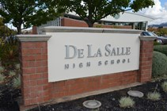**Meet the Schools of the Lasallian District of San Francisco New Orleans**: I’ve gotten away from introducing the schools of our new District, so it’s time to get back on track. So far I’ve highlighted La Salle High School in Yakima, WA, La Salle Catholic College Prep in Milwaukie, OR, De La Salle North Catholic in Portland, OR, Justin-Sienna High School in Napa, CA, Christian Brothers High School in Sacramento, St. Mary’s College HS in Berkeley, DeMarillac Academy and Sacred Heart Cathedral in San Francisco. This week, it’s De La Salle High School in Concord, CA. From the school’s website:

*De La Salle High School is a private Catholic high school for young men founded in 1965 by the De La Salle Christian Brothers of the District of San Francisco. De La Salle is located thirty miles east of San Francisco and primarily serves students of Contra Costa County. The campus, which lies on almost twenty acres, is characterized by openness and beauty, and can accommodate over 1,000 students. Its facilities include a 350-seat theater, library, large music facility, gymnasium, newly renovated pool complex, and athletic field complex, computer center, art studios and a new student center. The student population reflects the diversity found in the ethnic, cultural, and economic realities of the county, and the school encourages this diversity in the composition of its student body. The school population of approximately 1038 students is composed of African-American (5%), Latino/Hispanic(14%), Asian (3%), Caucasian (56%), Filipino (7%), multiracial(10%), American Indian(1%), Pacific Islander (1%) other (3%)…. The curriculum is coordinated with Carondelet High School, a private Catholic girls’ high school located across the street from De La Salle. Many upper-division classes are co-educational. Students are required to enroll in 6 class periods per day.*

*De La Salle does not provide class ranking for its students, but deciles are provided. Because the school has a selective student body and a college preparatory program, class rank could be misleading in determining a student’s ability to successfully complete college work. Any courses repeated to earn a higher mark or enrichment courses taken elsewhere are noted on the transcript but not calculated into the De La Salle cumulative G.P.A.*

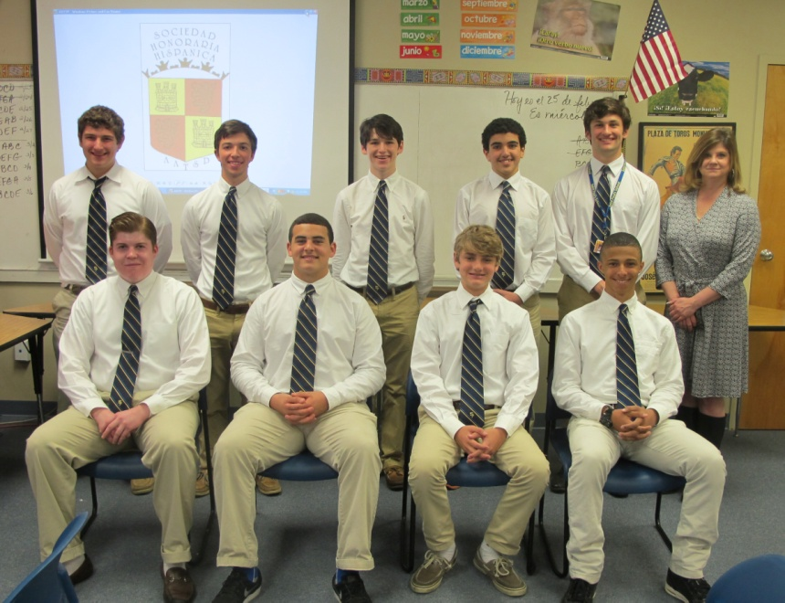The school is currently in the midst of a $55 million capital campaign for new academic, athletic, and arts buildings. They have raised $30 million. As the school’s president told me last summer, “The last 20 million is the hardest!” Hah! One of their families gave $25 million! Amazing! Where’s our family who’ll give us $25 mil? I’ll settle for $1 million or even $100,000! The school is also the home to legendary Coach Bob Ladouceur, who set a national record of 150 consecutive wins. He’s the subject of the major motion picture “When the Game Stands Tall.” All in all, DLS Concord is quite a school! But, then, so is SPS!

**Celebrity Waiters Dinner:** Come celebrate "The Swing Era" at our 2015 annual Spring fundraiser, The Celebrity Waiters' Dinner, on Thursday, March 5 2015 in the Briggs Assembly Center from 6:00 to 10:00 pm. This fun filled evening includes a full course meal, refreshments, entertainment and fellowship amongst St. Paul's families as well as the local business community. Proceeds from this event directly impact our students while supporting the College Tour, the student chapter of Habitat for Humanity, honor roll breakfasts and other special student recognitions, Life Skills Day for Seniors, etiquette training for pre- freshmen, Wolves on Wheels, Robotics and Aqua Robotics, our Mu Alpha Theta competitions and many more programs which enrich the experience of the young men here at St. Paul's. For more information, please Click Here. <http://www.stpauls.com/support/events/celebrity-waiters-dinner/>

*Newly inducted members of the Spanish Honor Society*

**PLEASE -- I Need Help With the Annual Fund: ANY amount is needed as** the new gym bills are coming in. Interested in having part of the new gym named after you? Just contact me and we’ll talk!

**IMPORTANT:** Many parents have not opened their Edline. We are using Edline for attendance contacting and for our SCHOOL EMERGENCY NOTIFICATION SYSTEM! PLEASE, PLEASE make sure you have activated your Edline account so you can receive important SPS notifications. Call Mike Holmes at 892-3200, ext 1044 if you need assistance. Parents need to create their own account and not rely on their son’s account.

**2015-16 Calendar:** St. Tammany Parish Public Schools has published next year’s calendar. They will begin on Fri, Aug 7. Accordingly, I have completed our calendar, which follows their calendar when possible. We must schedule 178 days per archdiocesan policy. **We therefore will start on Thursday, August 6 WITH A FULL DAY OF INSTRUCTION and NO book day – which corresponds to what we did this year. Please plan vacations accordingly.**

**Paper Wolf Update:** Please encourage your students to read The Paper Wolf on line ([www.thepaperwolf.com](http://www.thepaperwolf.com)) and read it yourself. Compliment the staff. Subscribe. Support the future.

**Important Driver’s License Requirement:** A new requirement was added to the driver's license issuance process for all minor applicants. All minor applicants must produce proof the applicant has either received a diploma or is currently enrolled in a high school program. This is done through a school attendance form from his or her high school prior to applying for a driver's license. These forms can be obtained in the administration building or the counseling center. **Several students went for licenses over the holidays and were turned away because they didn’t have the form – in some cases they waited several hours before being turned away!**

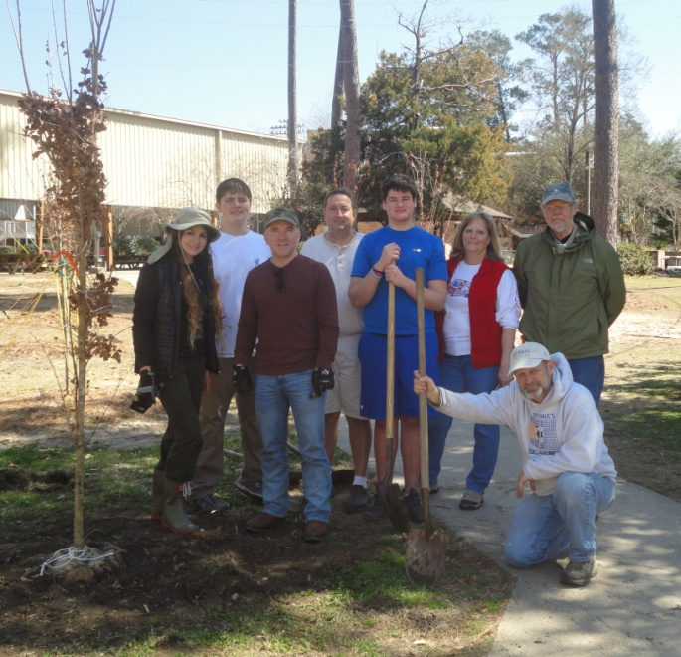**2015 Summer at Camp Abbey:** Camp Abbey, a ministry of the Office of the Archdiocese of New Orleans, has begun preparations for 2015 summer program and is seeking high school student applicants for junior counselor positions and graduating seniors, college students, and older for senior counselor and administrative positions. Although all positions are paid, staff may decline stipends in favor of service hours if applicable. Camp includes opportunities for prayer, Mass, the Sacrament of Reconciliation, and Eucharistic Adoration, as well as activities such as volleyball, basketball, softball, flag football, arts & crafts, archery, swimming, boating, performing arts, camping, and hiking.If you enjoy the outdoors, want to share your Catholic faith, and desire to serve as a mentor and role model, consider applying for summer staff at Camp Abbey. Boys’ camp staff serves during June 2015, and girls’ camp staff serves during July 2015. For more information or applications, visit [www.campabbey.org](http://www.campabbey.org) or contact [campabbey@arch-no.org](mailto:campabbey@arch-no.org) or 985-327-7240.

**From the Mothers Club:** The traditional Mother-Son Brunch will now be a Mother-Son Supper on Wednesday, April 22, at 6:30 in the Briggs Assembly Center. Since we can no longer hold school events on Sunday by directive of Archbishop Aymond and since the MC was not able to find a conflict-free Saturday, we will experiment this year with a weekday supper. Details will be sent by the MC later.

**H of the W:** More student answers to exam questions:

* *The nineteenth century was a time of a great many thoughts and inventions. People stopped reproducing by hand and started reproducing by machine. The invention of the steamboat caused a network of rivers to spring up. Cyrus McCormick invented the McCormick rapper, which did the work of a hundred men.*

*Planting group works Sat to enhance the campus.*

* *Louis Pasteur discovered a cure for rabbis. Charles Darwin was a naturalist who wrote the Organ of the Species. Madman Curie discovered radio. And Karl Marx became one of the Marx brothers.*
* *The First World War, caused by the assignation of the Arch-Duck by an anahist, ushered in a new error in the anals of human history*
* *Ancient Egypt was inhabited by mummies and they all wrote in hydraulics. They lived in the Sarah Dessert and traveled by Camelot. The climate of the Sarah is such that the inhabitants have to live elsewhere.*
* *The Bible is full of interesting caricatures. In the first book of the Bible, Guinessis, Adam and Eve were created from an apple tree. One of their children, Cain, asked, “Am I my brother’s son?”*
* *Shakespeare never made much money and is famous only because of his plays. He wrote tragedies, comedies, and hysterectomies, all in Islamic pentameter.*
* *Romeo and Juliet are an example of a heroic couplet.*
* OK, I’ll stop!

**A Look Ahead:**

March 9 – St. Joseph Altar – all periods meet (FGABCDE)

March 10 – Pack Time

March 13 – Third Quarter Ends – Juniors on Field Trip to WWII Museum

March 17 – ACT for all juniors in BAC

March 19 – Mass – Feast of St. Joseph

March 25 – Life Skills Day for Seniors

March 27 – Band and LYL at Team up Against Violence in Afternoon

March 31 – President’s Assembly

April 2 – Easter Holidays begin at 3:00 PM

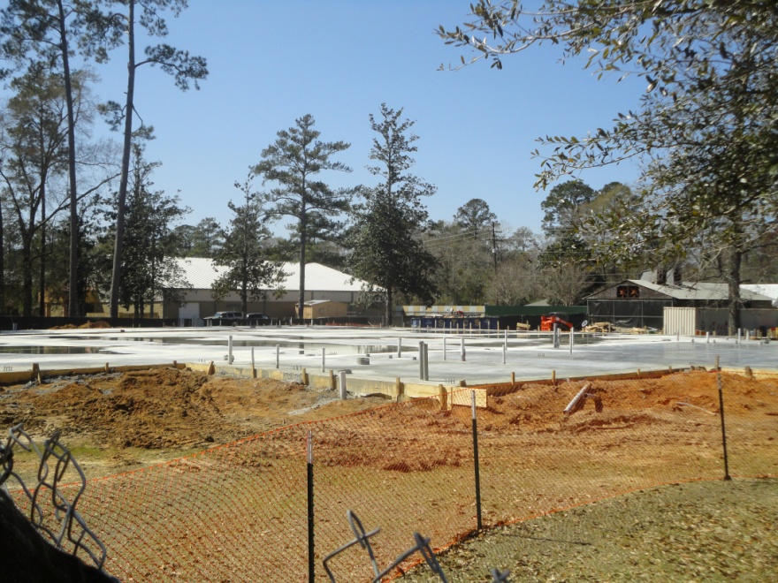April 13 – Leadership Week begins

April 14 – History of Covington presentation to juniors (Period G)

April 17 – Alumni Presentation assembly

April 20 – Founder’s Week begins

April 21 – President’s Assembly

April 23 – Feast of St. George Mass

April 24 – Field Day (B&C only meet)

April 29 – Jazz Band field trip to LPO

May 6-8 – Senior Exams

May 12 – Principal’s Assembly

May 13-15 – Pre Freshmen Exams

May 15 – Founder’s Day Mass

*Slab was poured last week for new gym. Contractor says they are one day behind schedule. Naming opportunities still available! Just contact me! Thanks!*

May 18 – Pre Freshmen Promotion

May 19-21 – Exam Schedules

May 22 – Faculty Records Day

Whew! Hope I wasn’t too long winded this week! And even though it’s 2015, I will still close with a paraphrase from one of my favorite NPR radio shows (which I’m listening to now as I write and LOLing): well, it’s happened again – you’ve squandered perfectly good time reading my ramblings!

Again, please let me know if there’s an issue you would like me to address in my newsletters or a question you think applies to others. Know of my prayer for you and your family, especially as we march forward through 2015! Again, thanks for being part of the 2014-15 edition of Saint Paul’s!

Brother Ray Bulliard, FSC

Glad to Be Back from San Diego as the 17th Christian Brother President of Saint Paul’s School

